Question sets for C – programming

1. Write a C program to assign 5 values and print them in Ascending and descending order.

2. To Accept 7 values in an array and sort them. Print largest and smallest value

3. Write a program in ‘C’ to input gross income (gi). The rate of income tax (itax) is as per following schedule :
Gross Income Rate of income Tax.
Less than or equal 60,000 Nil
Next 50,000 10%
Next 50,000 15%
Above 1,60,000 20%

4. A wholesaler gives discount on the basis of order amount as follows
First Rs. 8000 10% Discount
Next Rs. 2000 20% Discount
Excess 30% Discount
Write a program in ‘C’ to input customer name(cnm) and order amount(oamt) and print customer name, order amount and discount (dis).

5. Write a program in ‘C’ to input the roll number (rno) and marks (mks) of 10 students and print the results as follows:
Marks Class
>=60 I
<60 and >=50 II
<50 and >=35 III
Default No Class

- Write a C programme to accept marks of three subject and calculate total(sum), average(avg) and result if average >=45 then pass else fail?

- Rewrite the following sequence of if statements using switch ( )
if (code == 1) printf(“Mathematician\n”);
else if (code == 2) printf(“Computer Programmer\n”);
else if (code == 3) printf(“Psychologist\n”);
else printf(“Doctor\n”);

- Write a program in ‘C’ to input workers name, number of hours worked and his category and then print name and wage, where wage is computed on the basis of category as follows:
Category Rate / hour (Rs.)
A 75/-
B 60/-
C 40/-
else 30/-

- Electricity bill is computed on the basis of units consumed as follows:
Units Consumed Rate per unit
First 500 units Rs. 1.40 per Unit
Next 1000 units Rs. 1.60 per Unit
Excess Rs. 1.80 per Unit
If the bill amount exceeds Rs. 10,000 surcharge of 5% of bill amount is added to the bill. Write a ‘C’ program to input customer number, customer name, units consumed and then print customer number, customer name, and bill amount.

- Write a C program to calculate simple interest and compound interest print simple interest and table of Compound Interest

- Write a program in C to input cost of a car. Assuming that the rate of depreciation is 35%, calculate depreciated value for each of the first 5 years. Print the detail in table form with columns for year, depreciation of each year and depreciated value. Use WDV method.

- Write a program in ‘C’ to find and print the sum of 2²*3 + 4²*7 + 6²*11 + ……+ 20²*39

- Write a program in ‘C’ to input a character and display whether it is a vowel or not.
- Write a program in ‘C’ to find and print the sum of 1+2+3+ ….+10
- Write a program in ‘C’ to find and print the sum of 1/2+2/3+3/4+ ….+10/11

Question sets for: - Spreadsheets

- Create the following worksheet and perform the following:

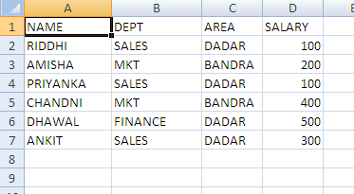
- Arrange the data in Alphabetical order of NAME.
- Arrange the data in Un-alphabetical (Z-A) order of NAME.
- Arrange the data in ascending order of SALARY.
- Arrange the data in Alphabetical order of DEPT and within DEPT ascending order of SALARY.
- Arrange the data in Alphabetical order of DEPT and within DEPT alphabetical order of NAME.

- Create the following worksheet and answer the following: (solved any five)

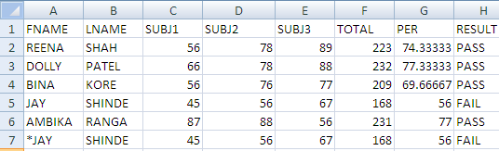
- To list only those records where FNAME starts with an alphabet “S”.
- To list only those records where LNAME ends with an alphabet “A”.
- To list only those records where LNAME has “N” as the second last character.
- To list only those records where RESULT is “PASS”.
- To list only those records where PER is more than 75 percent.

- Answer the following in MS-EXCEL. Consider the following worksheet

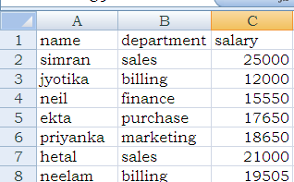
Write steps to obtain the department wise subtotals of the salary.

- The following data has been entered in a worksheet
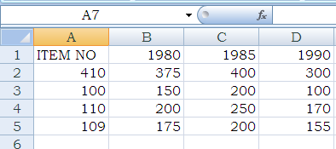
- To calculate the total in B6, C6 and D6
- To construct the 3-D Bar diagram
- To construct pie-chart diagram

- The following data has been entered in a worksheet

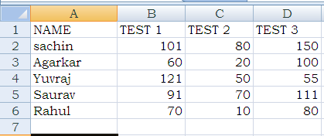
- Create Bar-chart
- Create Line chart
- Create Column chart

- The following data has been entered in a worksheet
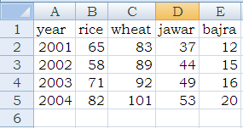
Based on these values, write steps
- To find the annual production in Column F
- To draw column chart of production of Rice and Wheat for 4 years
- To draw Pie chart for the production of year 2002.

- Prepare Pivot Table in cell A25 of the same worksheet, displaying CITY wise (1) average salary (2) maximum salary by taking CITY along row and SALARY in Data area

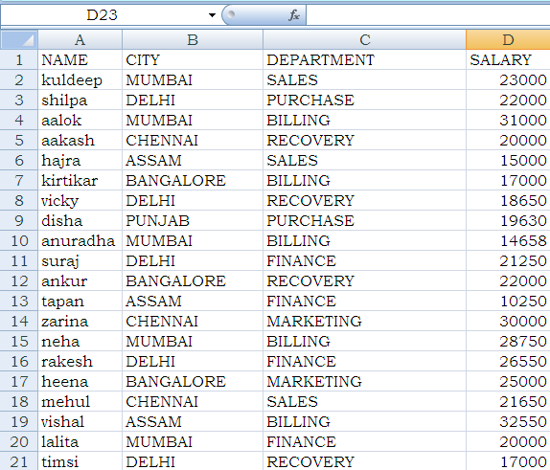

- Insurance agent’s name and his total business have been entered in column A and B respectively for 20 agents. First row contains heading next rows contain data. Write steps to compute commission and commission is 5% of the business upto to Rs 1,00,000 and 10% on additional business. Bonus is 2% of business exceeding Rs 5,00,000 only when business exceeds 5,00,00 otherwise it is 0.
- Answer the following
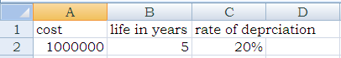
Using straight line method, explain the procedure to display year wise depreciation and depreciated value for each year till the life of Machinery. Use your own cell addresses.

- Consider the following worksheet containing the cost of an Asset, the rate of depreciation and the life of that asset in year. Using reducing balance method explain the procedure to display year-wise depreciation and the W.D.V for each year till the life of the Asset in column, D,E, and F respectively.
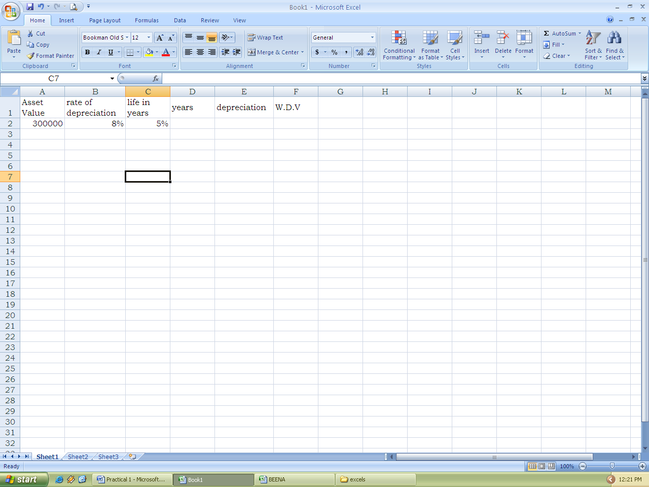

- Answer the following in MS-Excel. The following data has been entered in a worksheet
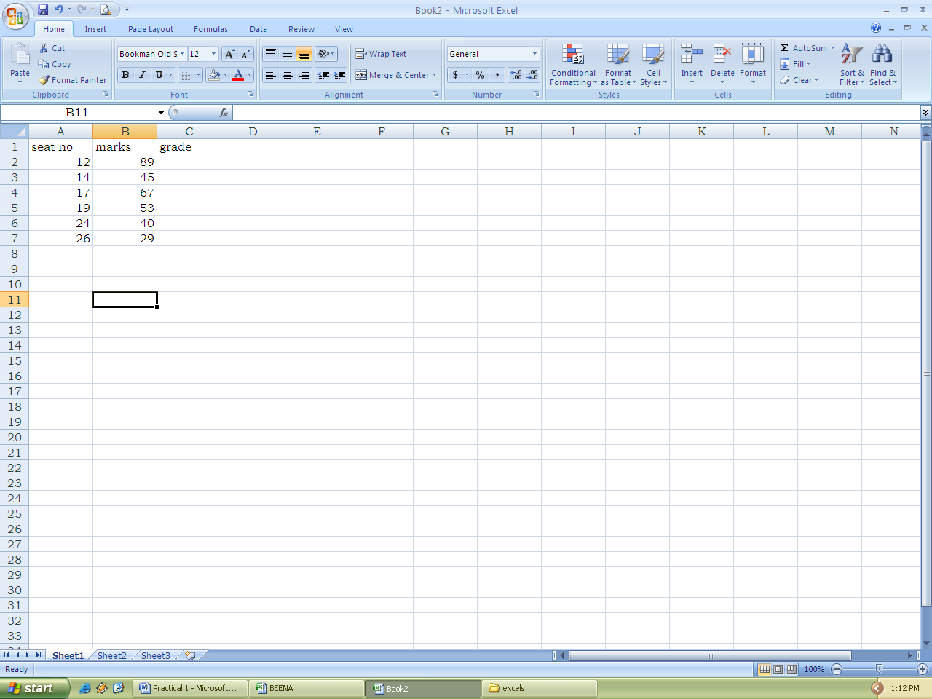
Write steps to compute the GRADE in column C as follows:
Marks Grade
Less than 45 C
45 or more and less than 60 B
60 and above A

- A worksheet contains employee number and monthly gross pay entered in column A and B respectively in the first 16 rows. In first row headings are entered and in remaining rows data is entered. Write steps to compute annual income and income tax in column C and D respectively where income tax is to be calculated as follows:
Annual income Income tax
First 100000 Nil
Next 100000 20%
Excess 30%

- Calculate total, average for the following worksheet
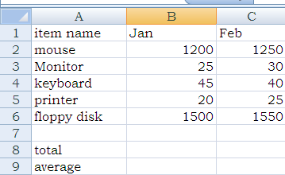
- Answer the following in Ms-Excel
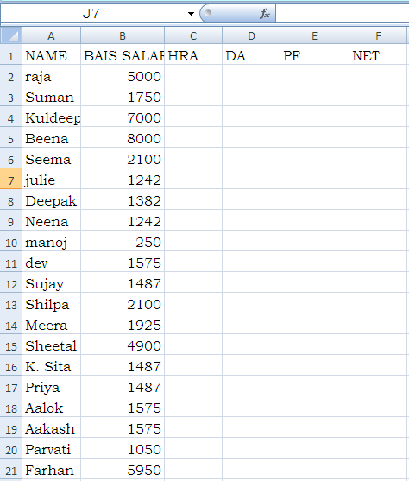
Explain the procedure to calculate (i) HRA as 20% of BASIC (ii) DA as 25% of BASIC (iii) Pf as 5% of BASIC (iv) Net as BASIC+HRA+DA-PF. Fill the entire worksheet.

- The following data has been entered in a worksheet
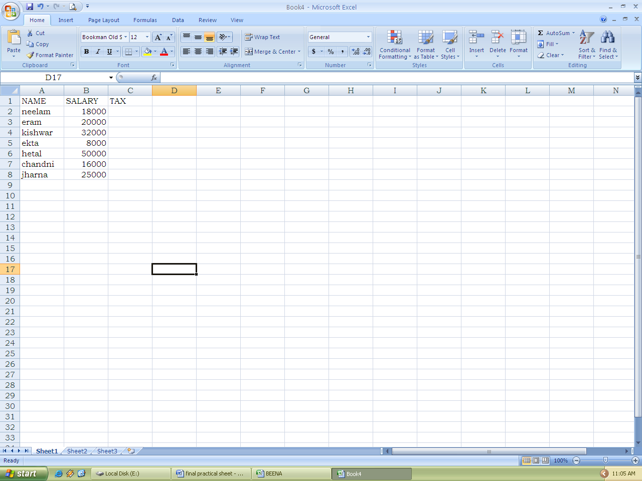
Write a formula in cell C2 to calculate tax as follows
SALES TAX
First Rs 10000 5%
NEXT 15000 8%
Excess 10%

- The following data has been entered in a worksheet
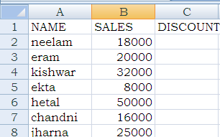
Write a formula in cell C2 to calculate discount as follows:
SALES DISCOUNT
First 10000 5%
Above Rs 10000 and upto Rs 25000 8%
Above Rs 25000 and upto Rs 40000 10%
Above Rs 40000 12%

QUESTION SET FOR :- MYSQL

I)
1. Open database “profile”.
1. Display all records from table cust_prof where uppercase ‘A’ is present in fname.
2. Open database “Book”.
- To find number of employees in each gender.
- To find average age for each gender.
II)
1. Open database “profile”.
- To display age, ignoring the duplicate from empl table.
2. Open database “Book”.
- To find number of employees in each gender.
- To find average age for each gender.
III)
1. Open database “profile”.
- Display emp_names from emp_prof where emp_name second character of emp_name is ‘a’ and last character of name is ‘s’.
2. Open database “Book”.
- To find minimum age, maximum age and average age for male employees.
- To produce the result as: Age of <name> is <age> years, for each employee.
IV)

1. Open database “profile”.
- Display fname and lname from cust_prof where lowercase ‘t’ is present in fname.
2. Open database “Book”.
- Write a query to display name, designation, age and date of joining separated by colon (:) sign.
- To display name of the employee and date of joining in the form Thursday, 9 July 2009.
V)
1. Open database “profile”.
- Display emp_name from emp_prof where emp_name has exact 5 charecters.
2. Open database “Book”.
- To find number of employees in each gender.
- To display reporting status of employees as “<employee name>, <designation of employee> is reporting to <boss name>, <designation of boss>.

VI)
1. Open database “profile”.
- Display emp_name from emp_prof where emp_name has exact 5 charecters.
2. Open database “Book”.
- To find average age for each gender.
- To display reporting status of employees as “<employee name>, <designation of employee> is reporting to <boss name>, <designation of boss>.

VII)
  - Open database “profile”.
  - Display emp_name and country where reperesenting country (‘india’,’australia’)
  - Display all records from table cust_prof where fname contains alphabet z.
- Open database “book”.
      - To find minimum age from each gender.
VIII)
- Open database “profile”
  - Display emp_names from emp_prof where emp_name second character of emp_name is ‘a’ and last character of name is ‘s’. (like ‘_a%s’)
- Open database “book”
  - To display number of employees working for each designation.
  - Display emp_names from emp_prof where 2nd last character of the name is ‘e’. (like ‘%e_’)
IX)
    - Open database book.
    - To display number of employees working for each designation
    - Write a query to display name, designation, age and date of joining separated by colon (:) sign.
    - Open database “profile”
    - Display emp_names from emp_prof where 2nd last character of the name is ‘e’. (like ‘%e_’)
X)
- Open Database Profile
- Display emp_names from emp_prof where emp_name second character of emp_name is ‘a’ and last character of name is ‘s’. (like ‘_a%s’)
- Open Database Book
- To display reporting status of employees as “<employee name>, <designation of employee> is reporting to <boss name>, <designation of boss>.
- To find minimum age, maximum age, and average age for each gender.

XI)
1. Open Database Profile
2. Display emp_name from emp_prof where emp_name second character of name is ‘a’ and contains ‘p’ somewhere after thereafter.(like ‘_a%p%’)
3. Open Database Book
4. To display reporting status of employees as “<employee name>, <designation of employee> is reporting to <boss name>, <designation of boss>.
5. To find number of employees in each gender.

XII)
1. Open Database Profile
2. Display emp_name from emp_prof where name contains ‘s’ first and then ‘i’ somewhere thereafter.
3. Display emp_name from emp_prof where emp_name has exact 5 charecters. ( like ‘_ _ _ _ _ ‘)
4. Open Database Book
5. To list name of employees and name of their boss. Label the two column properly (employee and boss)
XII)
1. Open Database Profile
1. Display all records from table cust_prof where uppercase ‘A’ is present in fname.
2. Display emp_name and country where reperesenting country (‘india’,’australia’)
2. Open Database Book
1. Using join display location, target and branch head, employee name from branch and empl table.

XIII)
1. Open Database Profile
1. Display emp_name from emp_prof where emp_name starting with alphabet s.
2. Open Database Book
1. To produce the output as: <name> is working as <desg>, and name the output is DESIGNATION.
2. To display age, ignoring the duplicate from empl table.
XIV)
1. Open Database Profile
1.Display emp_name and age where age is not below 25
2. Display emp_name from emp_prof where emp_name starting with alphabet s.

2. Open Database Book
- To list name of employees and name of their boss. Label the two column properly (employee and boss)

XV)
1. Open Database HRD
- Display “employee_id, first_name, last_name” in ascending order of first_name and last_name.
- Display all contents in descending order “employee_id”. (order by ….. desc)

2. Open Database Book
- To display number of employees working for each designation.

